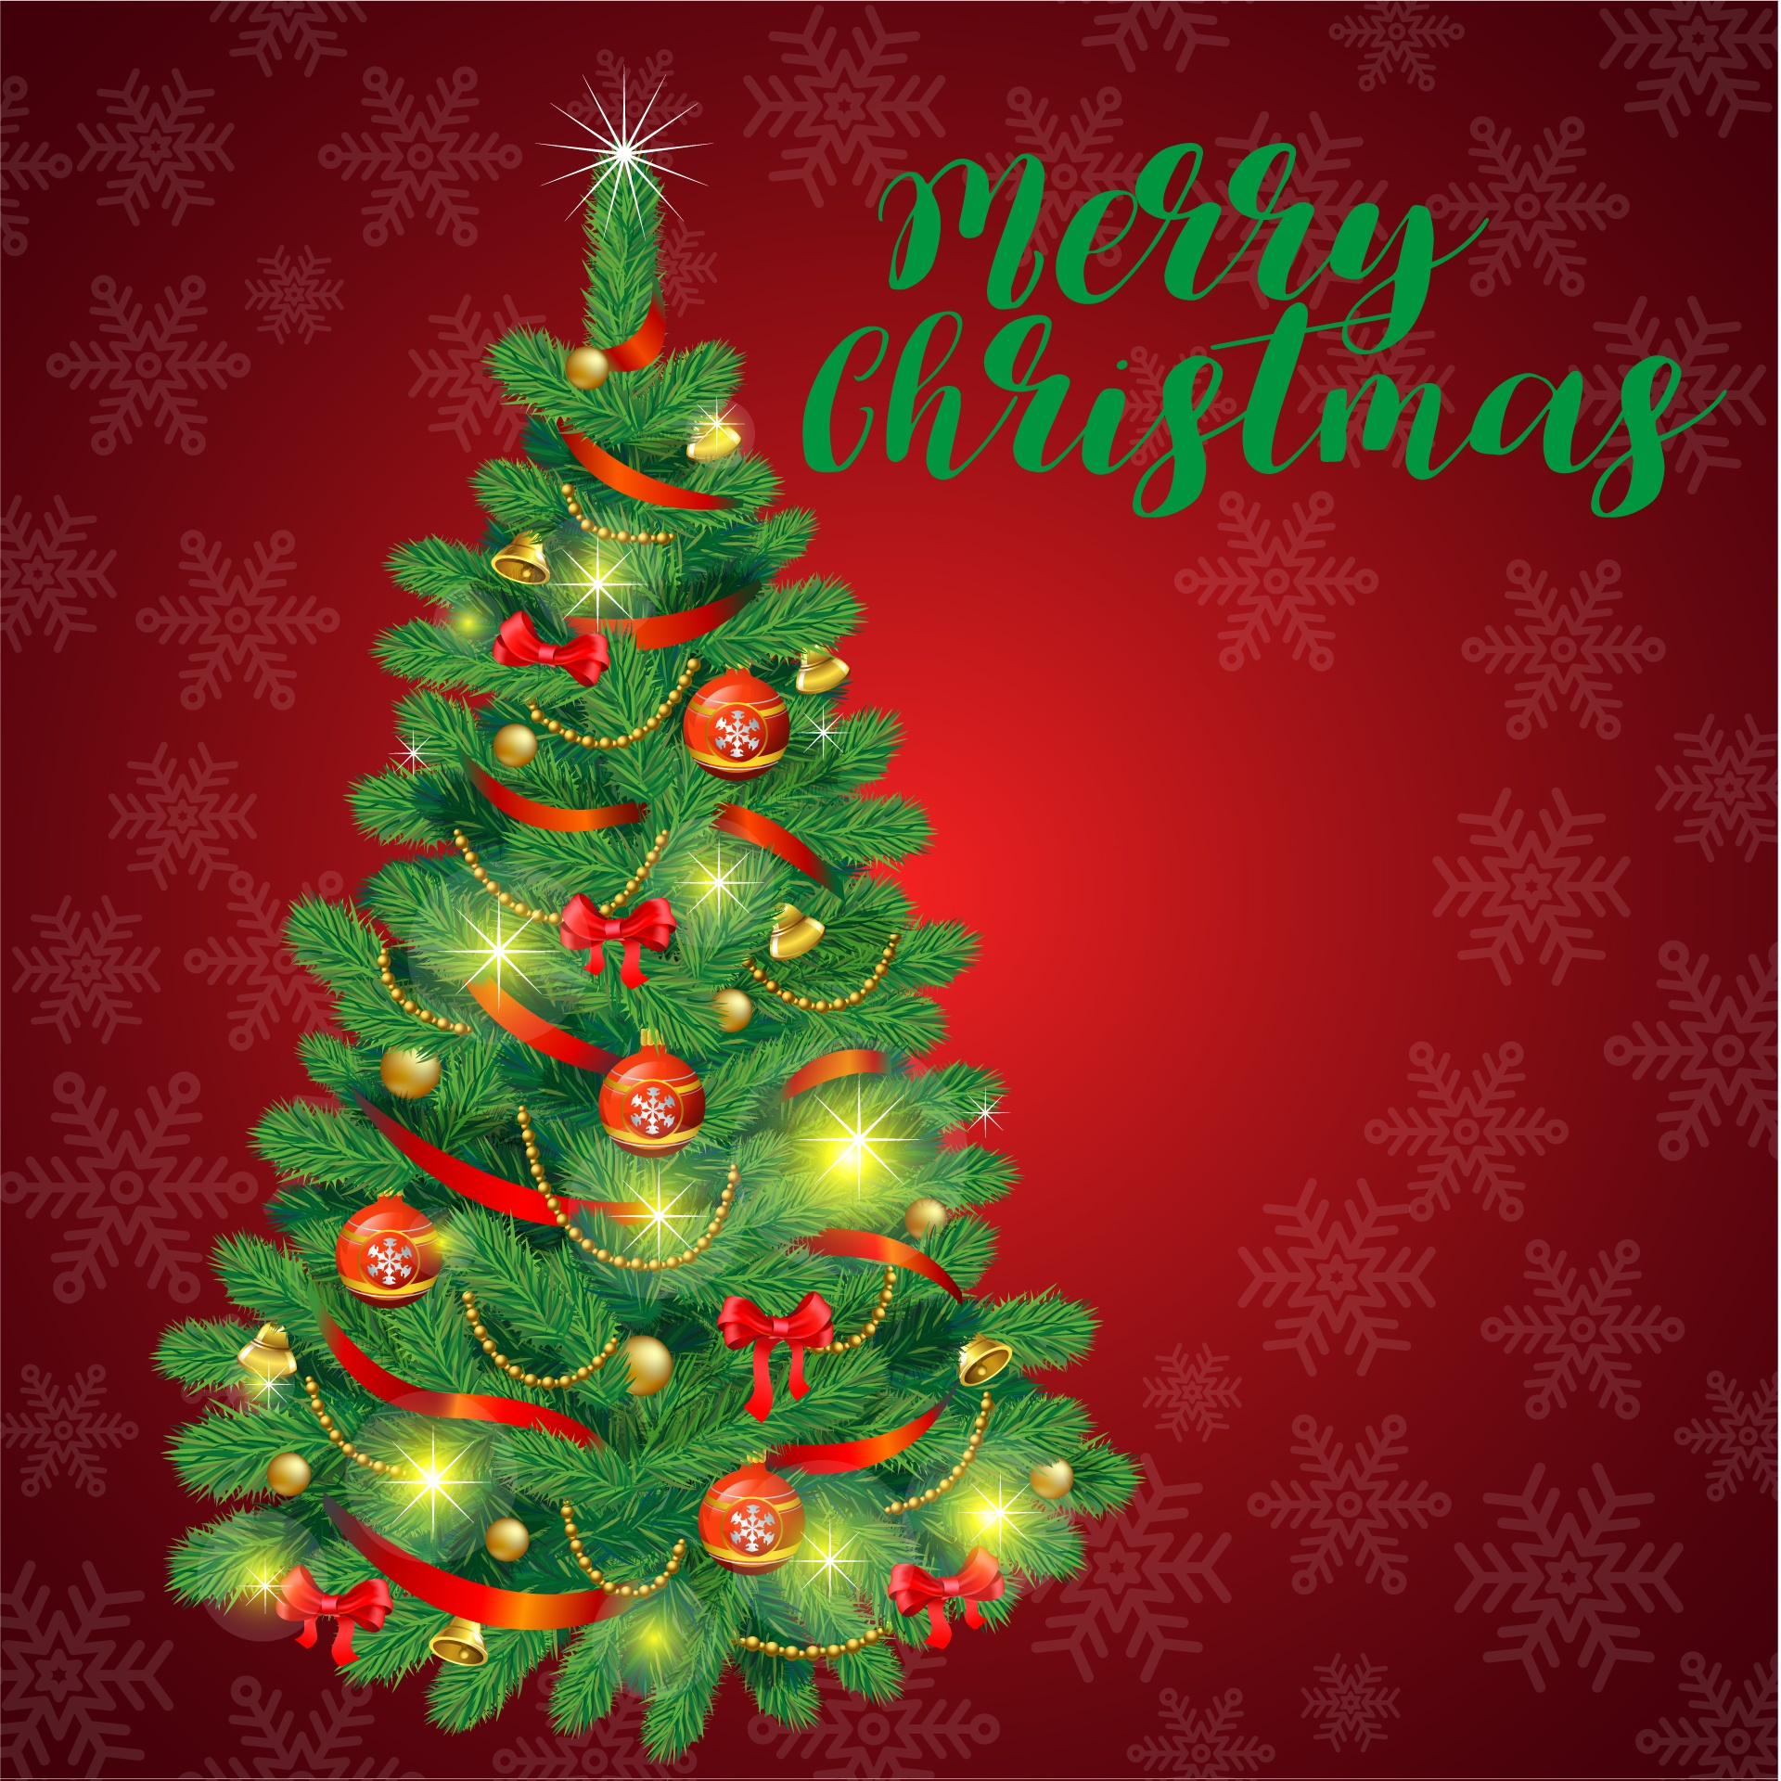
Christmas Fayre Menu
(Available every day from the 20/11/23 apart from Sundays)
2 Courses- £25.95 3 Courses- £29.95
Optional Coffee, Tea, and Mince pies £3.50

(v) Chefs Roasted Garlic & Parsnip Soup served with Bread & Butter
Cured Salmon & King Prawns Roulade on a bed of Garden Salad
Chefs Brussels Pate, Pedro Jimenez Cherries, Home Made Chutney, Garden Salad,
Toasted Bloomer & Butter
(V)Creamy Garlic & Gorgonzola Mushroom Bruschetta ,Side Salad
(V, Ve) Chefs Green Pesto, Hummus & Organic Avocado Tartare ,Toasted Ciabatta, Garden Salad

............

Shropshire Turkey, Roast Potatoes, Home Made Stuffing, Pigs in Blankets, Honey Roasted Parsnip, Gravy & Vegetables
12 Hour Braised Shropshire Farmed Beef in a Creamy Shallot & Forest Mushroom Sauce, Butter Mash & Vegetables
Fillet of Salmon in Chefs “Fish Bisque Sauce”, New Potatoes & Vegetables
(V,Ve) Mushroom & Vegetable Bourguignon, Sweet Potatoes Mash & Steamed Vegetables or (V)Chrismas Nut Roast Served with all the Trimmings
.............
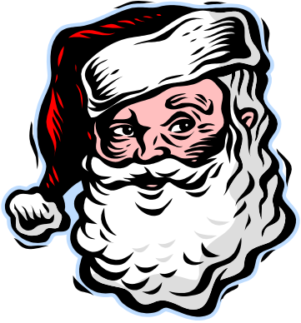
Homemade Cheese Cake & Double Cream
Bread & Butter Pudding with Hot Custard
Traditional Christmas pudding & Brandy Sauce
Duo of Cheshire Farms Ice cream or Selection of Sorbets with Fresh Fruits and Coulis
(please ask your server for today’s option of flavours)
Happy Holidays from us all at the Horseshoes!

